A study to compare website assessment methodologies will occur during the winter and spring 2015 quarters. One method is an established manual assessment method called the TEDS Assessment methodology. This method is done by trained individuals who become expert with the TEDS framework and methodology. The second method is also based on the TEDS assessment framework, but rather than training experts to have a deep understanding of the TEDS framework and how to do manual website assessments, online assessment instance links are distributed via email to non-expert users through an online tool called TedsRate. The TedsRate online assessment tool can be configured to provide non-experts a subset of whole assessment task along with instructions and context sensitive help to lessen the time and learning burden of doing a full assessment. TedsRate was built to simplify assessments into smaller chunks and to distribute these assessment instances to a larger base of assessors to reduce bias and improve consistency with a larger number of subject assessors.

Both the expert manual assessments and the TedsRate online assessments are be based on the TEDS Framework. This study aims to gain insight regarding how to most effectively use the TedsRate online tool in addition to learning how the aggregate assessment ratings gathered from these two methods differ.

TedsRate is already built and ready to be used but there are a few features to be implemented before we begin our study in order to improve user experience. We are looking for someone with PHP and MySQL expertise who would like to participate in this study. There will be opportunity to be a contributing author on a paper from this work.

Desired features to be added to TedsRate for our study include:

* Adding “Back” and “Forward” controls for the iframed website in TedsRate. This will enhance navigation for the user doing assessments. Currently the user needs to right click with the mouse to go back and forward within the iframe. The browser “Back” and “Forward” buttons control navigation to and from TedsRate itself.
* Adding a “Back to the “home” website” button to give the person doing the assessment quick access back to the initial page for the website they are evaluating.
* Adding configuration settings to allow for simple modifications to the TedsRate assessment tool. In current default UI mode, TedsRate is configured to be used by an assessor with some understanding how to use the TedsRate. We expect to use TedsRate with novice users in some circumstances and thus limit what information is needed to be displayed in TedsRate.
* Adding the ability for TedsRate to store more than one picture/document other artifact by the evaluator while doing an assessment. Currently they can only store one object in an assessment.
* Expanding the administration functions of TedsRate to allow for Editing and Deleting objects that have been created. Currently the basic adding of objects have been added in PHP from the Administration tool, but modifying and deleting is done through MySQL.

**TedsRate Specification**

TedsRate is an online site rating tool to allow researchers to configure, manage and distribute TEDS rating assessment instances to subjects via email.

There are two components to TedsRate, the administration of a rating project and the actual online rating assessment tool.

1. **TedsRate Online Rating Tool**:

The following screenshot shows TedsRate for a Sports Website Rating. In this example the website being evaluated is http://www.nba.com , however for this diagram the nba website is not shown, but instead is blank.

The user doing the assessment is able to navigate around the nba.com website to perform the scenario given for this particular assessment.

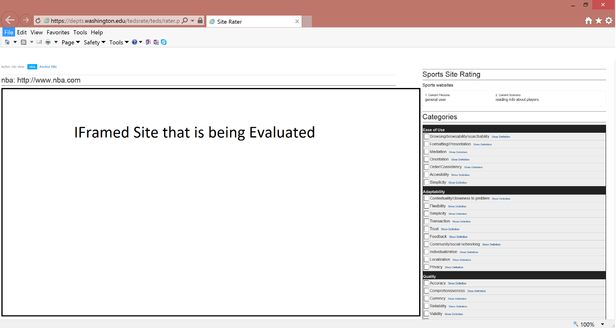

The site view can toggle to display the website being evaluated or an “Anchor site” which is an alternative website that the researchers have included as a reference for the person doing the assessment to compare how the evaluation website behaves in comparison to the anchor site.

On the top of the right side of the screen, the Persona, and Scenario for the assessment is provided. Below that, the TEDS categories are listed along with hover over definitions of each of the TEDS categories. The assessor rates each of the given TEDS categories on a Likert scale of 1 to 5 with 5 being excellent.

Once the user has completed rating the given categories, they scroll down the TedsRate page to add additional comment comments in a textbox, as well as attach screenshots or other objects to provide concrete reasons for their comments and ratings from the website.

1. **TedsRate Administration and Management of TEDS rating projects**

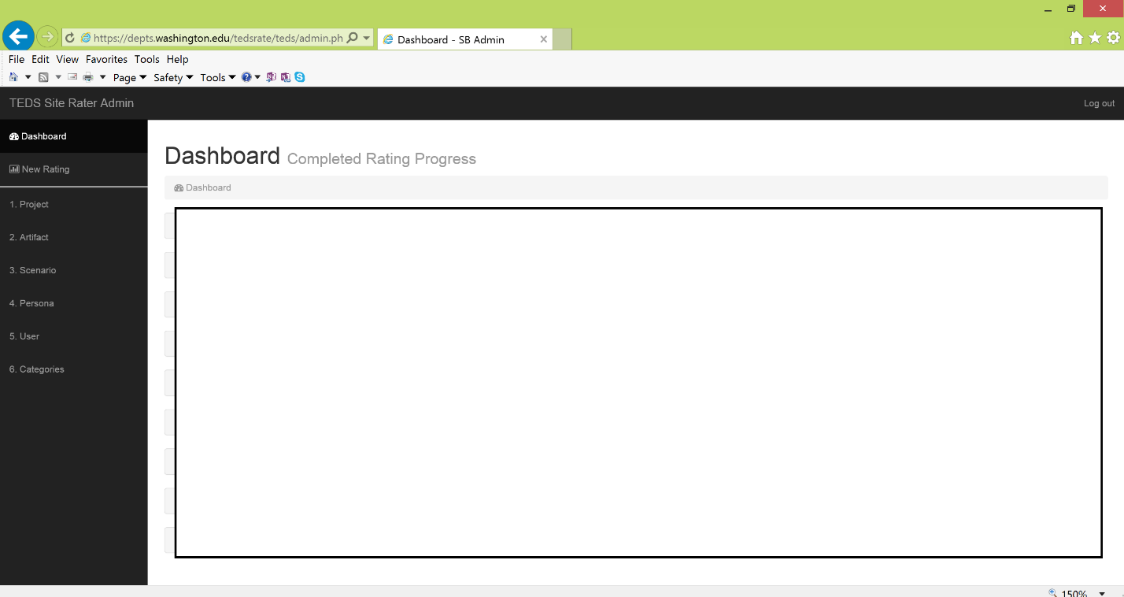

Project – In the TEDS methodology, a Project is a collection of all the rating assessments by users (subjects) who rate an artifact, using a specific scenario/persona combination using the selected TEDS categories. For example, one could create a project to have 10 users (subjects) rate the sounders website for purchasing tickets for a typical 18-50 year old soccer fan from Seattle using the full TEDS categories. The Artifact would be the sounders website. The Scenario would be purchasing tickets online through the website. The Persona would be an 18 – 50 year old soccer fan from Seattle. The Categories would be the 42 TEDS categories enumerated in the model.

Artifacts – Artifact refers to the website that is being assessed. Initially we expect this to be a soccer websites from around the world.

Scenario – Each TEDS assessment requires context to have meaning. The Scenario refers to the task the user is attempting to accomplish with the Artifact. Example scenarios for soccer websites are: buying tickets, looking at schedule/results, finding information about players on the team.

Persona – The Persona combines with the Scenario to bolster the context of the assessment. The Persona describes a type of user who is attempting to accomplish the task with the Artifact.

Users – Users are the people who are doing the ratings of the Artifact. In a research project we call them subjects. TedsRate allows users to be added to include an email alias so that the assessment instance can be sent to them as a link within an email.

Categories – TEDS contains 8 evaluation criteria broken into 40 distinct values that relate to quality of an information artifact. TedsRate allows a subset of these criteria/values to be included in an assessment rating instance. There are two reasons for this: First, by reducing the set of values the user (subject) is asked to complete in a rating instance, it reduces the time burden for each user to complete the instance. Completing a full rating assessment for all TEDS values can be a time consuming endeavor for a user and this allows the researcher to retain the power of the project with a reduced the time burden for each rating instance by increasing the number of users (subjects) included in the study. Second, it is believed that the just quality of an IS/IT artifact is context related, it is also theorized that a subset of the criteria/values are more relevant to a specific IS/IT artifact assessment for a given context. Thus, the researcher can remove criteria/values that are deemed non-relevant.